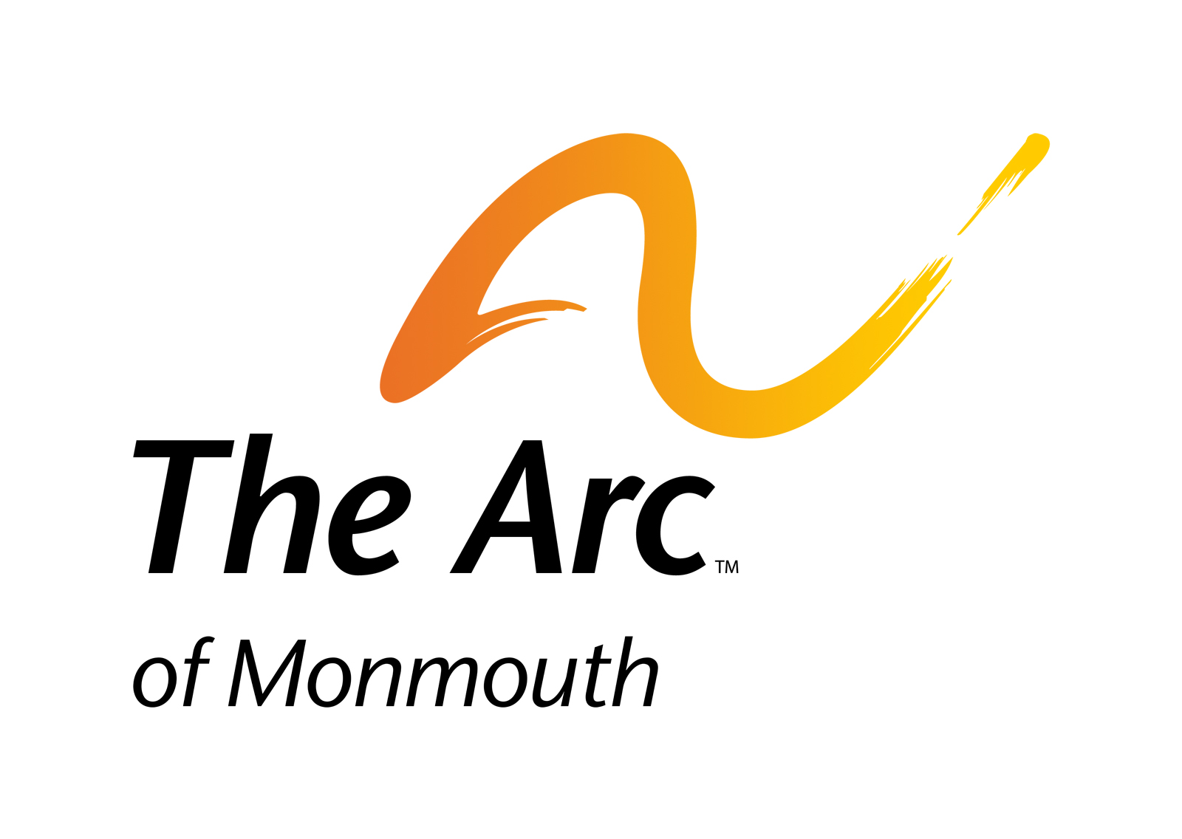

The Arc of Monmouth

1158 Wayside Road
Tinton Falls, NJ 07712

T 732-493-1919
F 732-493-3604
development@arcofmonmouth.org
www.arcofmonmouth.org

Achieve with us.

MEMBERSHIPS

Your Arc of Monmouth Membership:
- Is Tax Deductible
- Provides you with a discount to Recreation Program Fees
- Is also a membership with The Arc of New Jersey and The Arc of The United States.
- Supports all programs and services at The Arc of Monmouth
- Subscribes you to The Arc of Monmouth’s newsletter, The Turning Point.

All Members are recognized in The Turning Point newsletter.
Memberships of $100 or more are also recognized on a poster in The Arc Center lobby.

 Regular Member - $25 |  Supporting Member - $35
⁯ Patron - $50 |  Benefactor - $100
 President’s Council - $200 and above
____ I wish to make an additional tax-deductible gift of $____________
____ My check (made payable to The Arc of Monmouth) is enclosed
____ Please charge the credit card I’ve listed below
Name:________________________________________________________________________
Address: ______________________________________________________________________
Telephone: __________________________________ Fax #: ____________________________
Email:________________________________________________________________________
Amount $______________
Charge to: ____Visa ____ MasterCard ____ Amex
Account #________________________________________ Expiration Date: _______
Signature_____________________________________________________________
______ New Member ______Renewal
 Parent/Foster Parent/Sibling of Person with developmental disabilities |  Self Advocate
⁯ Professional in field of developmental disabilities |  Other interested person
⁯ Please contact me about volunteering my time for Arc.
Please complete this form and send in one of the following methods:
Mail: The Arc of Monmouth, 1158 Wayside Road, Tinton Falls, NJ 07712
Fax: (732) 493-3604
Email: development@arcofmonmouth.org

The Arc of Monmouth is a 501(c)(3) nonprofit organization, and contributions are tax deductible to the fullest extent allowable by law. We advise you to consult with a tax professional for a final determination.
Federal EIN: 210-657-022 NJ Charities Registration # 2292-00775

