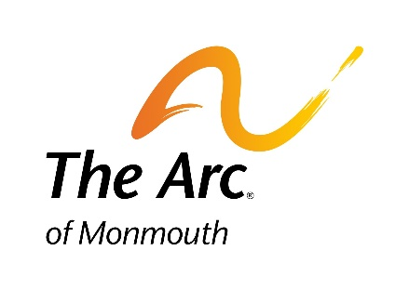

Kach (Keep Achieving) at Brookdale Community College
2020-2021 Student Application Checklist

Your completed application packet includes the following:
- Student Application (7 pages, available online as a PDF)
- Individualized Education Program (IEP)
- Educational Evaluation
- Psychological Evaluation
- Two (2) Letters of Recommendation
- Proof of Legal Guardianship (if student is not a self-guardian)

Please send the completed Student Application and all additional documents to
Karen E. Halloran
Coordinator, Kach (Keep Achieving at Brookdale Community College)
The Arc of Monmouth
1158 Wayside Road
Tinton Falls, NJ 07712

Application Deadline: Friday, April 17, 2020
Interviews will be scheduled for May, 2020

*Please note, due to the expected volume of applications, not all applicants will be invited to an interview.

