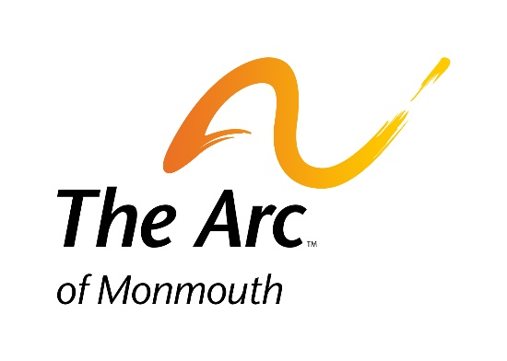

The Arc of Monmouth

1158 Wayside Road
Tinton Falls, NJ 07712

T 732-493-1919
F 732-493-3604
www.arcofmonmouth.org

Achieve with us.

Winter 2020 Session
Interest Selection Form
DUE DATE: Friday, November 22, 2019
Please fill out the form below. The Achievement Zone staff will review your selections. You will receive a confirmation of your choices promptly. You may fax this interest form to: (732) 493-3604

Name: _____________________________________________Date:____/____/____

Please check off the activities you are interested in attending:

Monday, Option 1 – Creative Expressions (Community Inclusion)
Monday, Option 2 – Inventory, Money Management & Technology (Prevocational Training)
Tuesday Option 1 – Gardening & Drama (Prevocational Training)
Tuesday Option 2 – Wandering Wagon & Job Club (Prevocational Training
Tuesday Option 3 – Book Club & Therapeutic Martial Arts (Community Inclusion)
Wednesday, Option 1 – Community Service & Job Club (Prevocational Training)
Wednesday, Option 2 – Community Visits (Community Inclusion)
Wednesday, Option 3 – Group Respite
Thursday Option 1 –Drama with Travel Training & Dance (Community Inclusion)
Thursday Option 2 – Group Respite
Friday Option 1 – Let’s Do Lunch (Prevocational Training)
Friday Option 2 – Community College Connection/Yoga/Nutrition (Community Inclusion)
Friday 7 Week Option – Historic New Jersey (Community Inclusion)

